**שאלה 1**

Explore the distribution of rincome (reported income). What makes the default bar chart hard to understand? How could you improve the plot?

My first attempt is to use geom_bar() with the default settings.

rincome_plot <-

gss_cat %>%

**ggplot**(**aes**(x = rincome)) +

**geom_bar**()

rincome_plot

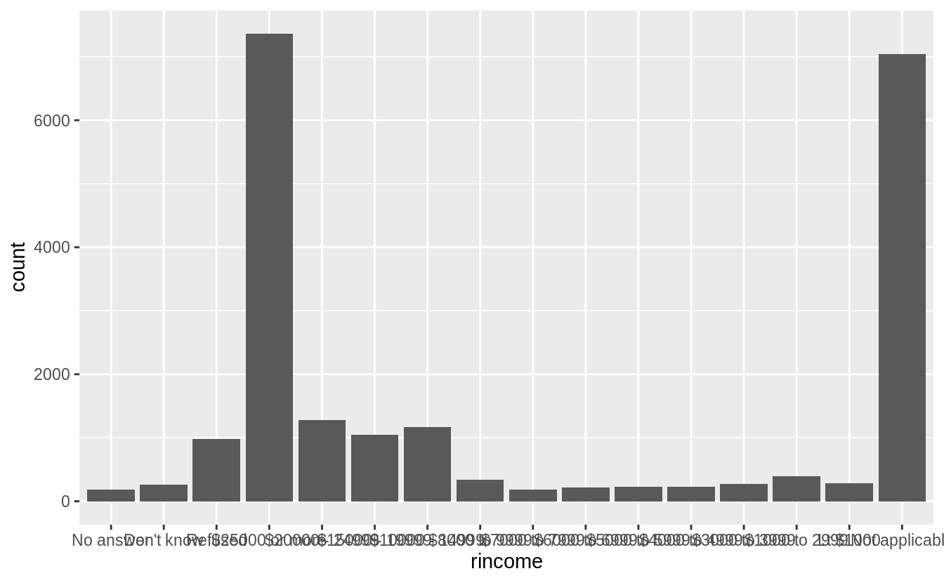

The problem with default bar chart settings, are that the labels overlapping and impossible to read. I’ll try changing the angle of the x-axis labels to vertical so that they will not overlap.

rincome_plot +

**theme**(axis.text.x = **element_text**(angle = 90, hjust = 1))

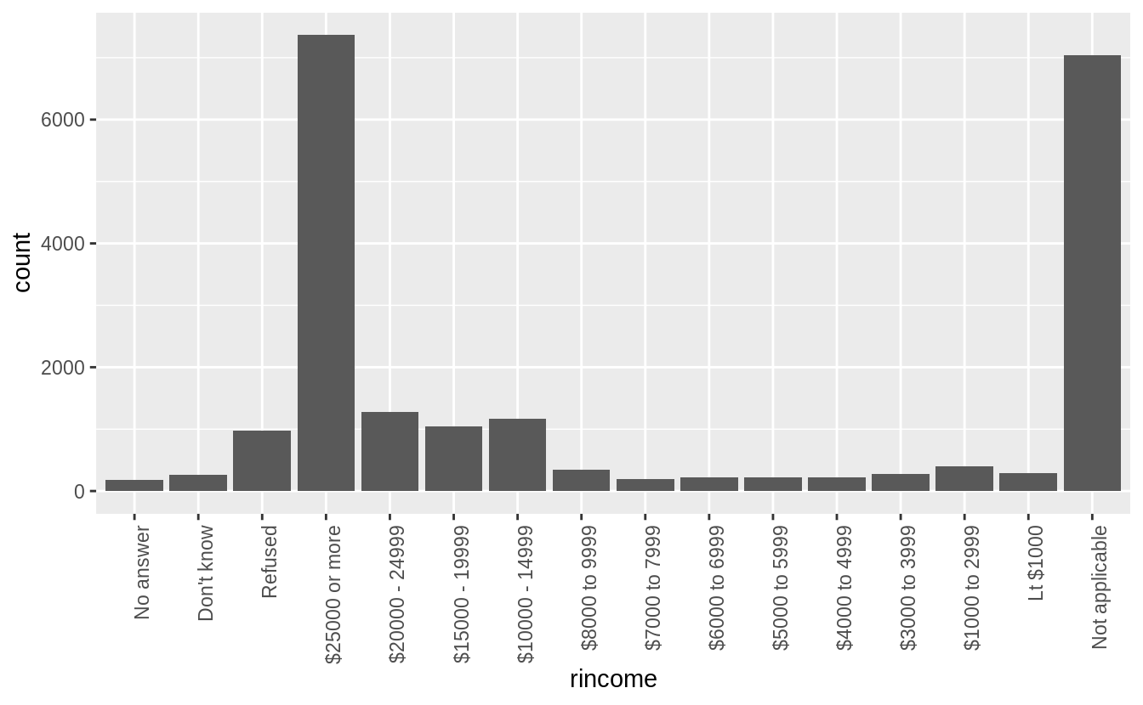

This is better because the labels are not overlapping, but also difficult to read because the labels are vertical. I could try angling the labels so that they are easier to read, but not overlapping.

rincome_plot +

**theme**(axis.text.x = **element_text**(angle = 45, hjust = 1))

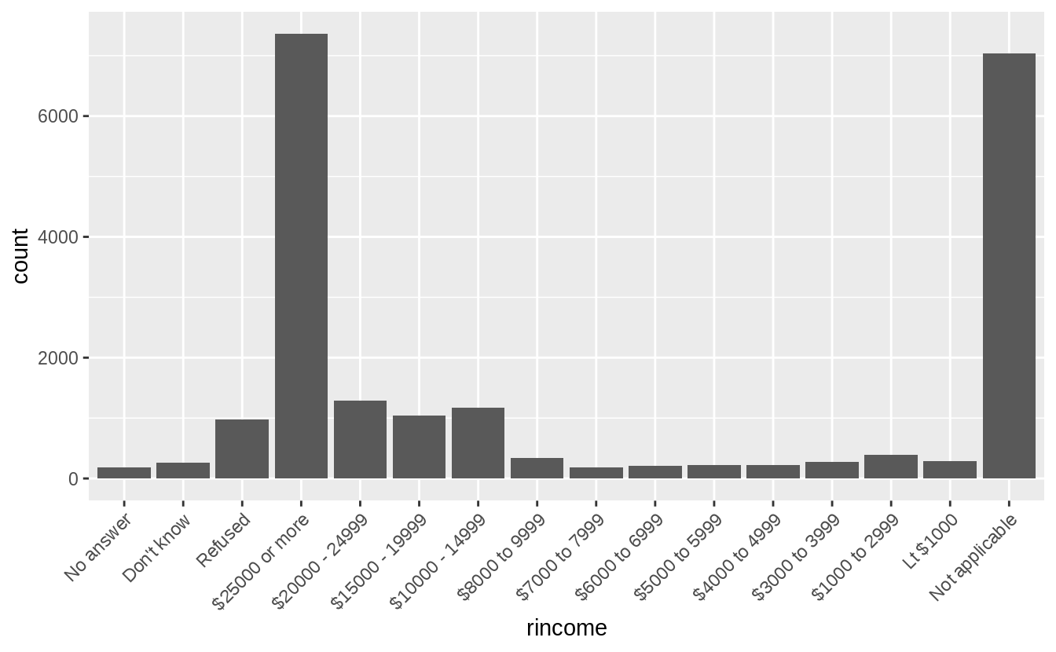

But the solution I prefer for bar charts with long labels is to flip the axes, so that the bars are horizontal. Then the category labels are also horizontal, and easy to read.

rincome_plot +

**coord_flip**()

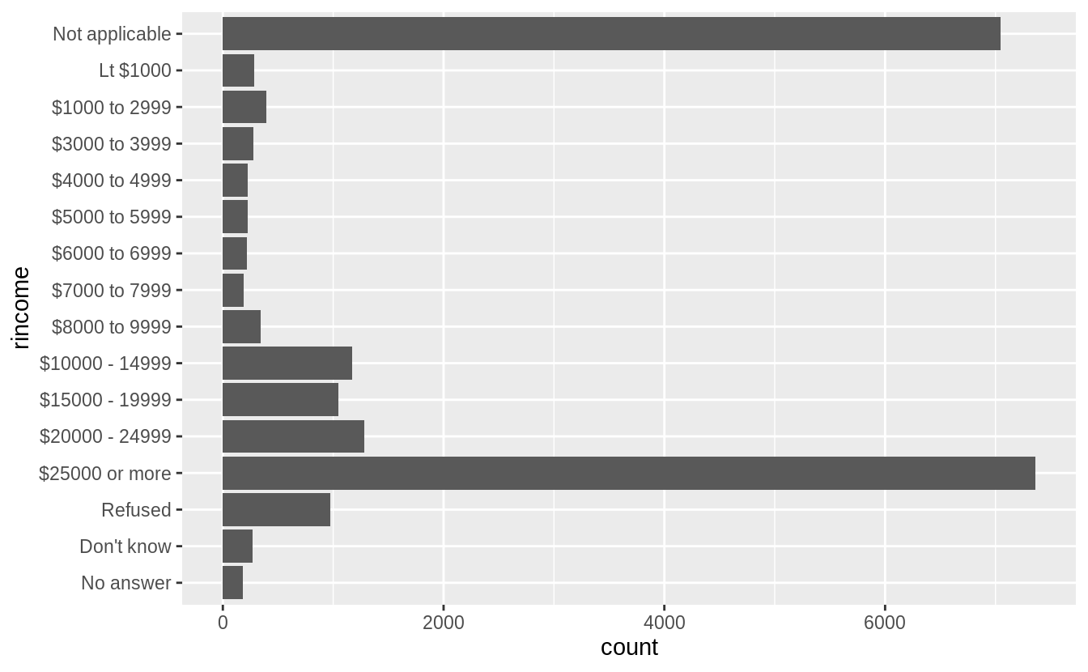

Though more than asked for in this question, I could further improve this plot by

1. removing the “Not applicable” responses,
2. renaming “Lt $1000” to “Less than $1000”,
3. using color to distinguish non-response categories (“Refused”, “Don’t know”, and “No answer”) from income levels (“Lt $1000”, …),
4. adding meaningful y- and x-axis titles, and
5. formatting the counts axis labels to use commas.

gss_cat %>%

**filter**(!rincome %in% **c**("Not applicable")) %>%

**mutate**(rincome = **fct_recode**(rincome,

"Less than $1000" = "Lt $1000"

)) %>%

**mutate**(rincome_na = rincome %in% **c**("Refused", "Don't know", "No answer")) %>%

**ggplot**(**aes**(x = rincome, fill = rincome_na)) +

**geom_bar**() +

**coord_flip**() +

**scale_y_continuous**("Number of Respondents", labels = scales::comma) +

**scale_x_discrete**("Respondent's Income") +

**scale_fill_manual**(values = **c**("FALSE" = "black", "TRUE" = "gray")) +

**theme**(legend.position = "None")

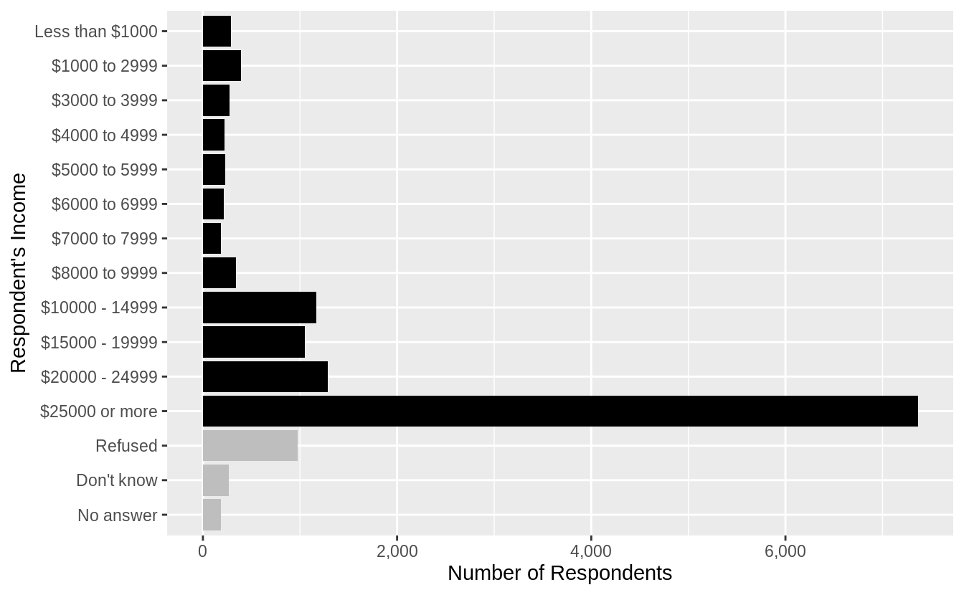

If I were only interested in non-missing responses, then I could drop all respondents who answered “Not applicable”, “Refused”, “Don’t know”, or “No answer”.

gss_cat %>%

**filter**(!rincome %in% **c**("Not applicable", "Don't know", "No answer", "Refused")) %>%

**mutate**(rincome = **fct_recode**(rincome,

"Less than $1000" = "Lt $1000"

)) %>%

**ggplot**(**aes**(x = rincome)) +

**geom_bar**() +

**coord_flip**() +

**scale_y_continuous**("Number of Respondents", labels = scales::comma) +

**scale_x_discrete**("Respondent's Income")

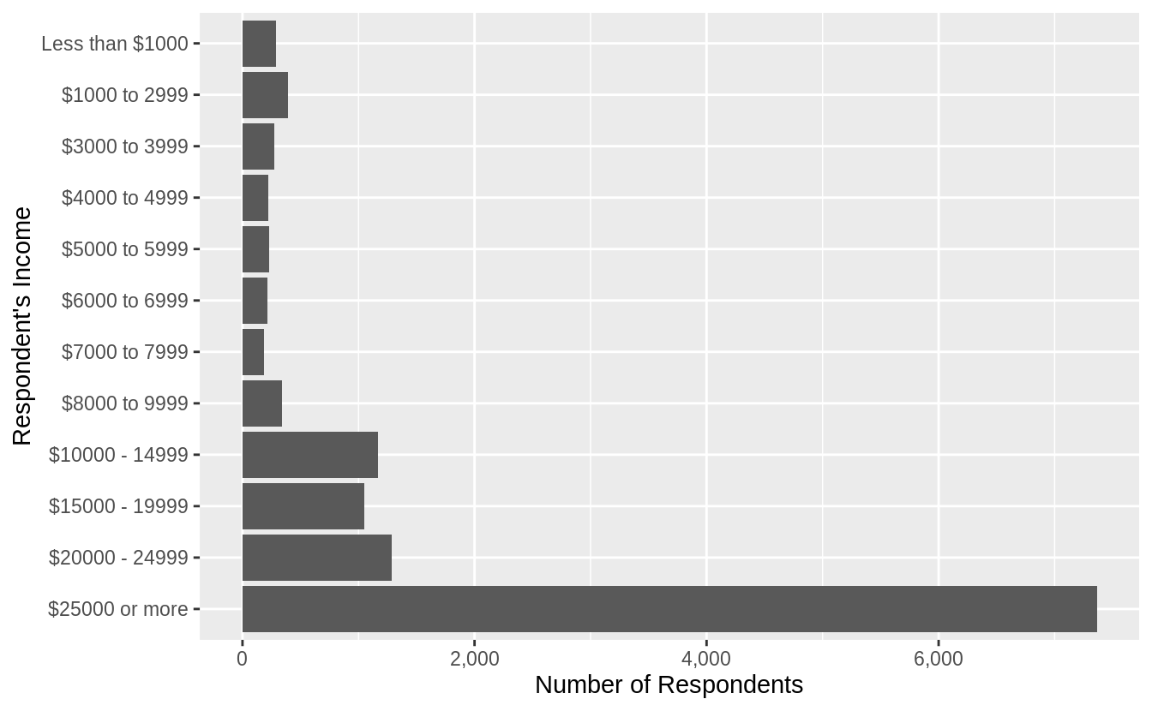

A side-effect of coord_flip() is that the label ordering on the x-axis, from lowest (top) to highest (bottom) is counterintuitive. The next section introduces a function fct_reorder() which can help with this.

**שאלה 2**

What is the most common relig in this survey? What’s the most common partyid?

The most common relig is “Protestant”

gss_cat %>%

**count**(relig) %>%

**arrange**(**desc**(n)) %>%

**head**(1)

*#> # A tibble: 1 x 2*

*#> relig n*

*#> <fct> <int>*

*#> 1 Protestant 10846*

The most common partyid is “Independent”

gss_cat %>%

**count**(partyid) %>%

**arrange**(**desc**(n)) %>%

**head**(1)

*#> # A tibble: 1 x 2*

*#> partyid n*

*#> <fct> <int>*

*#> 1 Independent 4119*

**שאלה 3**

There are some suspiciously high numbers in tvhours. Is the mean a good summary?

**summary**(gss_cat[["tvhours"]])

*#> Min. 1st Qu. Median Mean 3rd Qu. Max. NA's*

*#> 0 1 2 3 4 24 10146*

gss_cat %>%

**filter**(!**is.na**(tvhours)) %>%

**ggplot**(**aes**(x = tvhours)) +

**geom_histogram**(binwidth = 1)

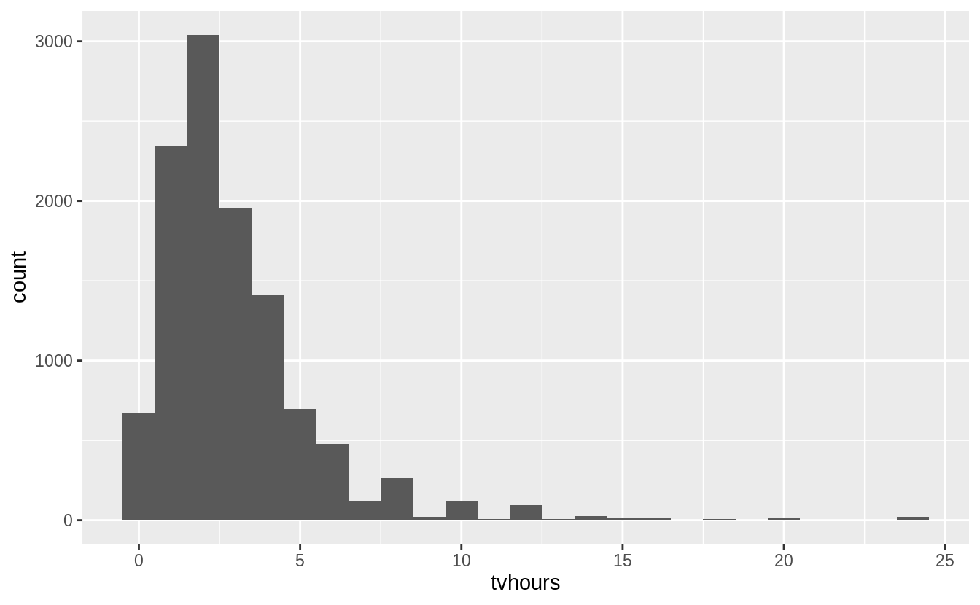

Whether the mean is the best summary depends on what you are using it for :-), i.e. your objective. But probably the median would be what most people prefer. And the hours of TV doesn’t look that surprising to me.

**שאלה 4**

For each factor in gss_cat identify whether the order of the levels is arbitrary or principled.

The following piece of code uses functions introduced in Ch 21, to print out the names of only the factors.

**keep**(gss_cat, is.factor) %>% **names**()

*#> [1] "marital" "race" "rincome" "partyid" "relig" "denom"*

There are six categorical variables: marital, race, rincome, partyid, relig, and denom.

The ordering of marital is “somewhat principled”. There is some sort of logic in that the levels are grouped “never married”, married at some point (separated, divorced, widowed), and “married”; though it would seem that “Never Married”, “Divorced”, “Widowed”, “Separated”, “Married” might be more natural. I find that the question of ordering can be determined by the level of aggregation in a categorical variable, and there can be more “partially ordered” factors than one would expect.

**levels**(gss_cat[["marital"]])

*#> [1] "No answer" "Never married" "Separated" "Divorced"*

*#> [5] "Widowed" "Married"*

gss_cat %>%

**ggplot**(**aes**(x = marital)) +

**geom_bar**()

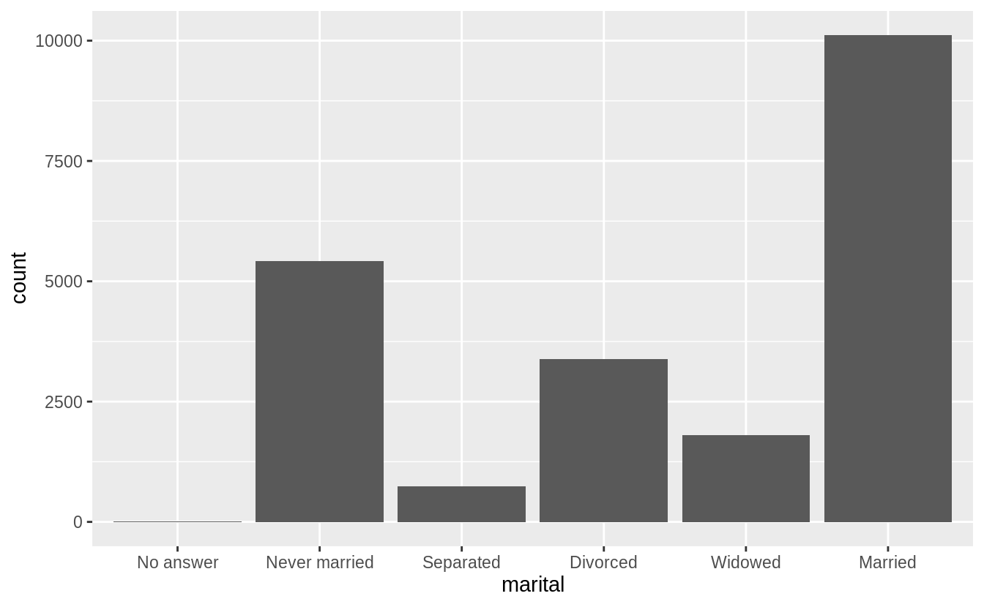

The ordering of race is principled in that the categories are ordered by count of observations in the data.

**levels**(gss_cat$race)

*#> [1] "Other" "Black" "White" "Not applicable"*

gss_cat %>%

**ggplot**(**aes**(race)) +

**geom_bar**() +

**scale_x_discrete**(drop = FALSE)

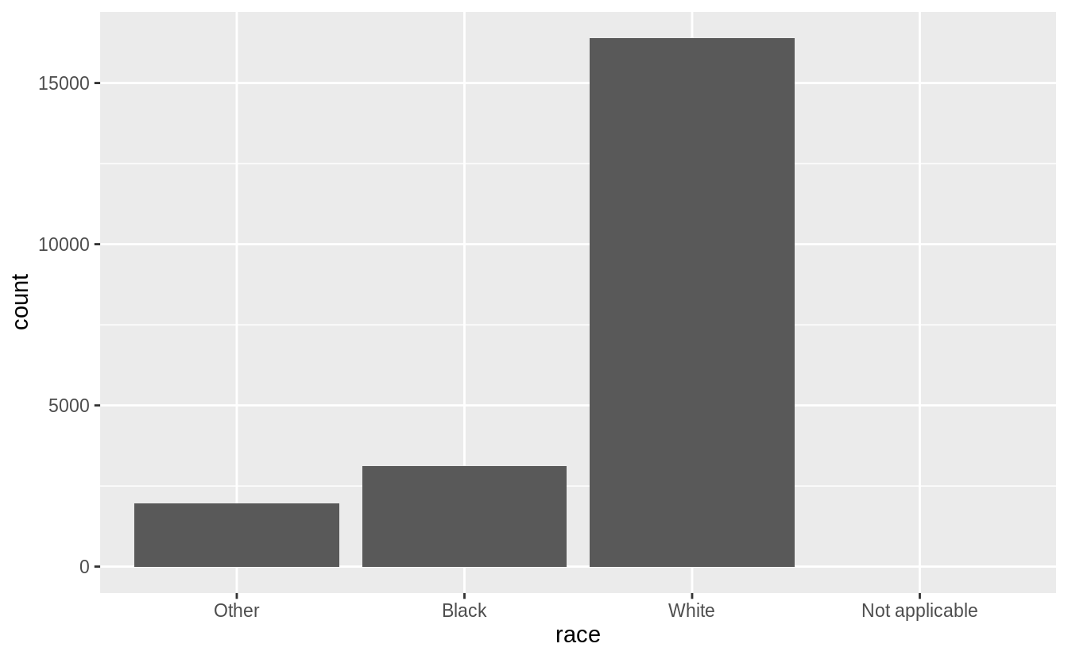

The levels of rincome are ordered in decreasing order of the income; however the placement of “No answer”, “Don’t know”, and “Refused” before, and “Not applicable” after the income levels is arbitrary. It would be better to place all the missing income level categories either before or after all the known values.

**levels**(gss_cat$rincome)

*#> [1] "No answer" "Don't know" "Refused" "$25000 or more"*

*#> [5] "$20000 - 24999" "$15000 - 19999" "$10000 - 14999" "$8000 to 9999"*

*#> [9] "$7000 to 7999" "$6000 to 6999" "$5000 to 5999" "$4000 to 4999"*

*#> [13] "$3000 to 3999" "$1000 to 2999" "Lt $1000" "Not applicable"*

The levels of relig is arbitrary: there is no natural ordering, and they don’t appear to be ordered by stats within the dataset.

**levels**(gss_cat$relig)

*#> [1] "No answer" "Don't know"*

*#> [3] "Inter-nondenominational" "Native american"*

*#> [5] "Christian" "Orthodox-christian"*

*#> [7] "Moslem/islam" "Other eastern"*

*#> [9] "Hinduism" "Buddhism"*

*#> [11] "Other" "None"*

*#> [13] "Jewish" "Catholic"*

*#> [15] "Protestant" "Not applicable"*

gss_cat %>%

**ggplot**(**aes**(relig)) +

**geom_bar**() +

**coord_flip**()

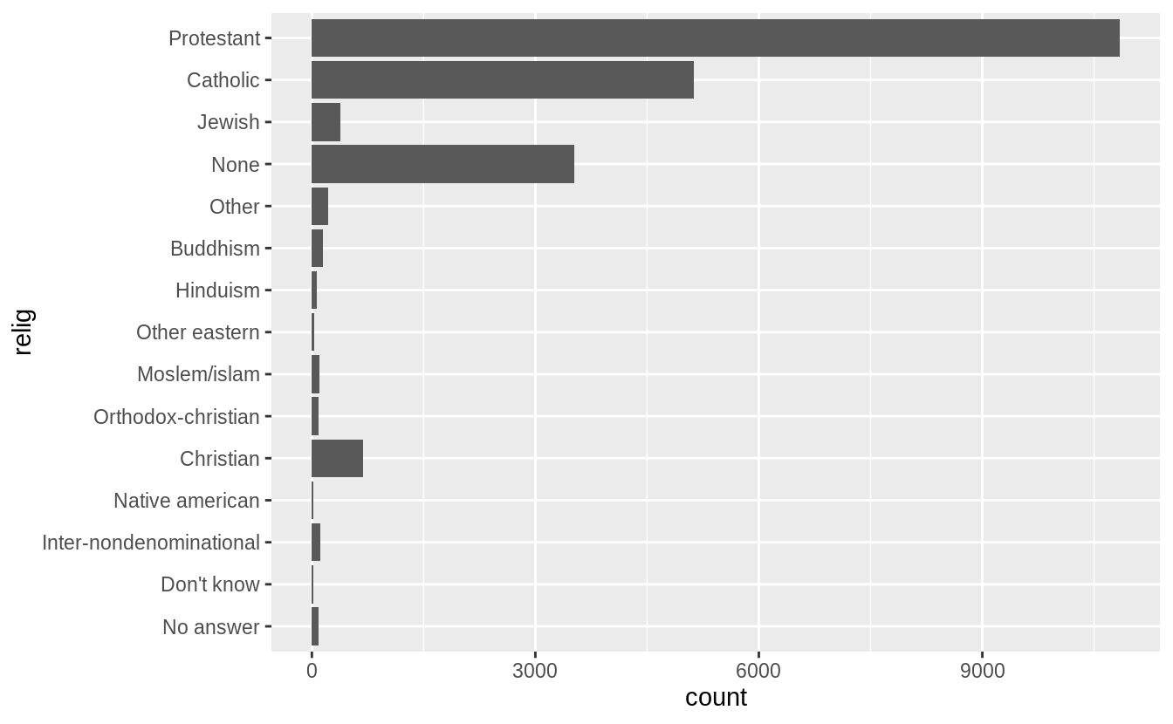

The same goes for denom.

**levels**(gss_cat$denom)

*#> [1] "No answer" "Don't know" "No denomination"*

*#> [4] "Other" "Episcopal" "Presbyterian-dk wh"*

*#> [7] "Presbyterian, merged" "Other presbyterian" "United pres ch in us"*

*#> [10] "Presbyterian c in us" "Lutheran-dk which" "Evangelical luth"*

*#> [13] "Other lutheran" "Wi evan luth synod" "Lutheran-mo synod"*

*#> [16] "Luth ch in america" "Am lutheran" "Methodist-dk which"*

*#> [19] "Other methodist" "United methodist" "Afr meth ep zion"*

*#> [22] "Afr meth episcopal" "Baptist-dk which" "Other baptists"*

*#> [25] "Southern baptist" "Nat bapt conv usa" "Nat bapt conv of am"*

*#> [28] "Am bapt ch in usa" "Am baptist asso" "Not applicable"*

Ignoring “No answer”, “Don’t know”, and “Other party”, the levels of partyid are ordered from “Strong Republican”" to “Strong Democrat”.

**levels**(gss_cat$partyid)

*#> [1] "No answer" "Don't know" "Other party"*

*#> [4] "Strong republican" "Not str republican" "Ind,near rep"*

*#> [7] "Independent" "Ind,near dem" "Not str democrat"*

*#> [10] "Strong democrat"*

**שאלה 5**

How have the proportions of people identifying as Democrat, Republican, and Independent changed over time?

To answer that, we need to combine the multiple levels into Democrat, Republican, and Independent

**levels**(gss_cat$partyid)

*#> [1] "No answer" "Don't know" "Other party"*

*#> [4] "Strong republican" "Not str republican" "Ind,near rep"*

*#> [7] "Independent" "Ind,near dem" "Not str democrat"*

*#> [10] "Strong democrat"*

gss_cat %>%

**mutate**(

partyid =

**fct_collapse**(partyid,

other = **c**("No answer", "Don't know", "Other party"),

rep = **c**("Strong republican", "Not str republican"),

ind = **c**("Ind,near rep", "Independent", "Ind,near dem"),

dem = **c**("Not str democrat", "Strong democrat")

)

) %>%

**count**(year, partyid) %>%

**group_by**(year) %>%

**mutate**(p = n / **sum**(n)) %>%

**ggplot**(**aes**(

x = year, y = p,

colour = **fct_reorder2**(partyid, year, p)

)) +

**geom_point**() +

**geom_line**() +

**labs**(colour = "Party ID.")

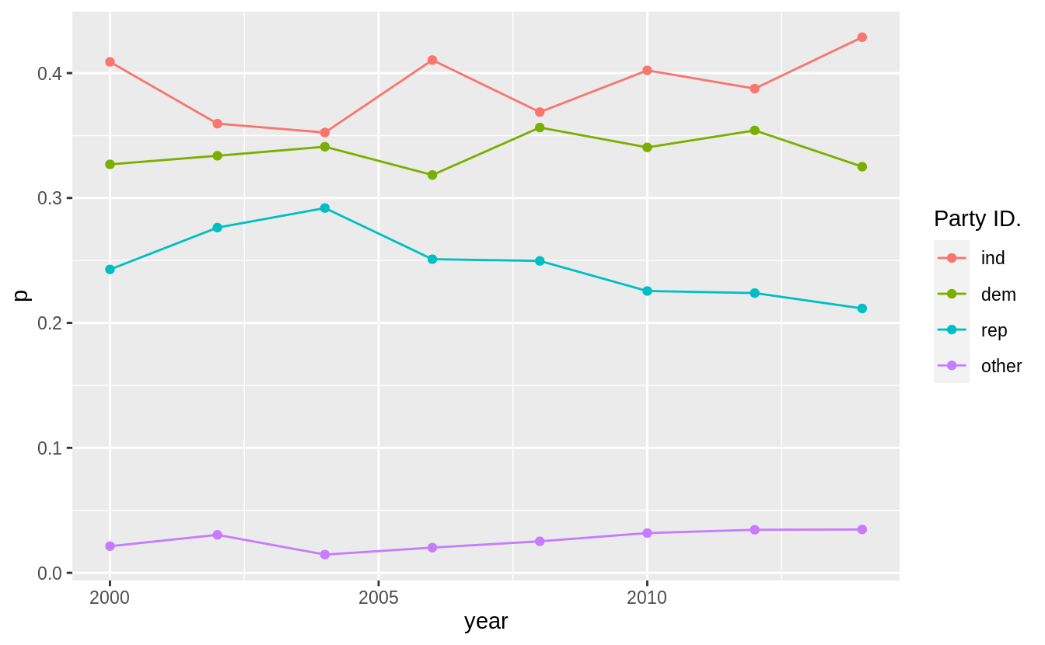

**שאלה 6**

How could you collapse rincome into a small set of categories?

Group all the non-responses into one category, and then group other categories into a smaller number. Since there is a clear ordering, we would not use fct_lump().`

**levels**(gss_cat$rincome)

*#> [1] "No answer" "Don't know" "Refused" "$25000 or more"*

*#> [5] "$20000 - 24999" "$15000 - 19999" "$10000 - 14999" "$8000 to 9999"*

*#> [9] "$7000 to 7999" "$6000 to 6999" "$5000 to 5999" "$4000 to 4999"*

*#> [13] "$3000 to 3999" "$1000 to 2999" "Lt $1000" "Not applicable"*

**library**("stringr")

gss_cat %>%

**mutate**(

rincome =

**fct_collapse**(

rincome,

`Unknown` = **c**("No answer", "Don't know", "Refused", "Not applicable"),

`Lt $5000` = **c**("Lt $1000", **str_c**(

"$", **c**("1000", "3000", "4000"),

" to ", **c**("2999", "3999", "4999")

)),

`$5000 to 10000` = **str_c**(

"$", **c**("5000", "6000", "7000", "8000"),

" to ", **c**("5999", "6999", "7999", "9999")

)

)

) %>%

**ggplot**(**aes**(x = rincome)) +

**geom_bar**() +

**coord_flip**()

